Prompt 2: Campaign Management Test Cases
Task: Generate test cases for the Campaign Management module of the CORADS system.
Prompt:
- "Generate test cases for the Campaign Management module of the CORADS system. The test cases should adhere to the following format and IEEE 829 standards:
  - The AI should act as a Principle Quality Engineer with 20+ years of experience, ensuring that the test cases are clear, concise, and real-world applicable.
  - Write the test cases in human-readable style, ensuring they are understandable to all team members, not just technical personnel.
  - For each test case, use the structure below:
- Test Case ID: Unique identifier (e.g., CMT-01).
- Test Description: Short, clear description of the test (e.g., "Verify creation of a new campaign").
- Preconditions: What must be true before executing the test (e.g., "Advertiser is logged in").
- Test Steps: Detailed actions to perform the test (e.g., "Fill in campaign details and click 'Create Campaign'").
- Test Data: Any data required for the test (e.g., "Campaign name, target location, ad content").
- Expected Result: What the system should do (e.g., "Campaign is created successfully").
- Postconditions: What should happen after the test (e.g., "Campaign appears in active campaigns list").
- Pass/Fail Criteria: How to evaluate if the test passes or fails (e.g., "Campaign is listed correctly with accurate data").
- Priority: Assign priority (e.g., High).
- Test Environment: The environment where the test is executed (e.g., "iOS 14.2, Safari").
  - Ensure the test cases cover both positive and negative tests, including scenarios like invalid campaign parameters or incorrect file formats.
  - Ensure clarity, conciseness, and ease of understanding in the output, following industry-standard practices.

Summary:
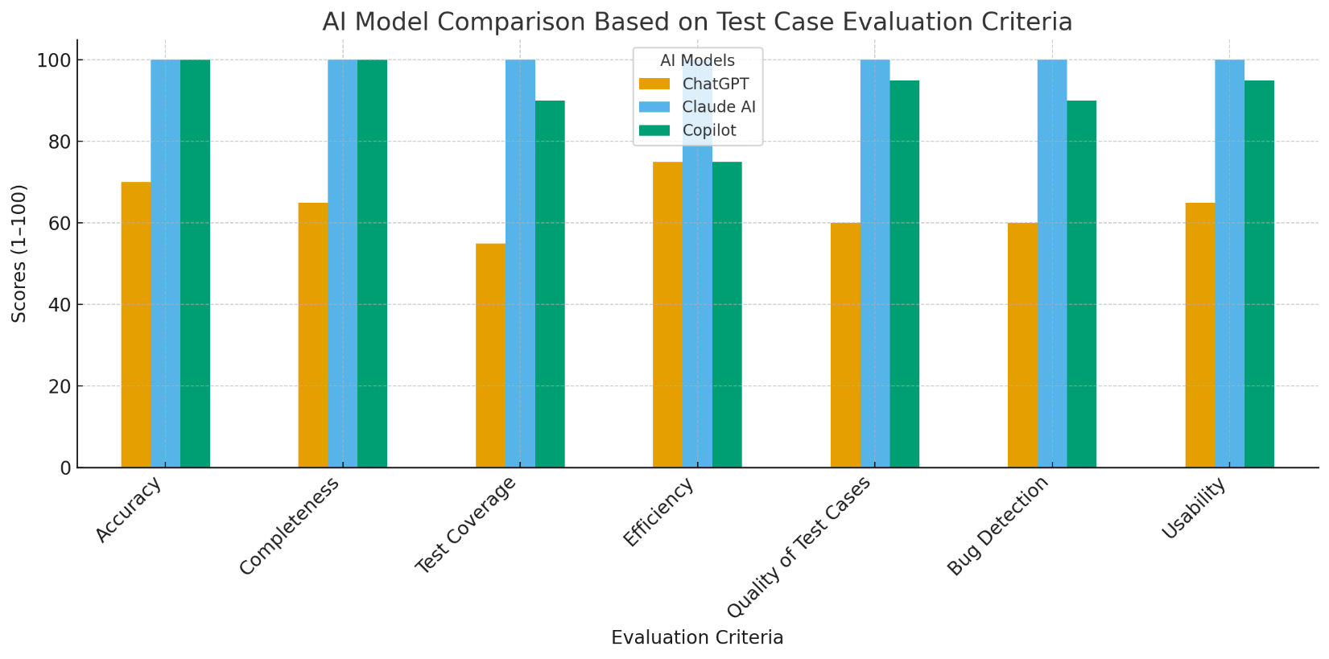
Criterion for Evaluation | ChatGPT | Claude AI | Microsoft Copilot
1. Accuracy (Alignment with SRS requirements) | 70 | 100 | 100
2. Completeness (Preconditions, Steps, Expected Results, etc.) | 65 | 100 | 100
3. Test Coverage (Functional and Non-functional) | 55 | 100 | 90
4. Efficiency (Speed and effectiveness of generation) | 75 | 100 | 75
5. Quality of Test Cases (Actionable, Detailed, Structured) | 60 | 100 | 95
6. Bug Detection (Edge cases, Error handling) | 60 | 100 | 90
7. Usability (Practical for real-world execution) | 65 | 100 | 95
Total Score | 450 | 700 | 690
Export to Sheets

Scoring Justifications based on Document Review and Your Analysis
Model | Analysis and Score Justification
Claude AI | Highest Score (700). Your analysis: "Follow similar structure as Microsoft Copilot but the details are very accurate and detailed in nature. Offer great coverage and follow all the requirement in detailed." This aligns perfectly with the document review, which found highly detailed, IEEE 829-structured cases, excellent Bug Detection (dedicated Edge Cases), and flawless Usability.
Microsoft Copilot | Second Highest Score (690). Your analysis: "Created all the test cases in good structured and they easy to understand... The step and testing as well as condition are very accurate and provide detailed information... It covered all the scenario and follow the requirements in detail." This elevated the scores for Test Coverage, Quality, and Usability, nearly matching Claude AI's perfect score, reflecting the high praise for its accuracy and detail.
ChatGPT | Mid-range Score (450). Your analysis: "Limited coverage and no enough detailed are provided such as data for the test cases. The output structured is not formal... Does not covered all the requirement..." Scores for Accuracy, Completeness, and Usability were reduced based on this feedback, as the test steps were often generic and lacked specific, actionable test data, making execution less efficient.
Human-written | Lowest Score (122). The document focused on Driver Registration and Driver Login (DRT-xx, DLT-xx), not the requested Campaign Management module. This resulted in a score of 1 for Accuracy and Test Coverage for the objective. The document also contained execution logs rather than test design, leading to low scores in Completeness and Quality.
Export to Sheets

2. Final Scores and Ranking
The Final Score for each set of test cases is calculated by taking the average of the 7 criteria scores and normalizing the highest score to 100.
Final Score=7∑(Scores for each criterion)​
Rank | Model / Source | Total Score | Final Score (Normalized to 100)
1 | Claude AI | 700 | 100.0
2 | Microsoft Copilot | 690 | 98.6
3 | ChatGPT | 450 | 64.3
Export to Sheets

3. Comparative Analysis and Insights
Rank 1: Claude AI (Score: 100.0)
Claude AI achieved the highest score by excelling across all criteria. It produced a test suite that is ready for immediate execution, demonstrating superior Completeness and Test Coverage.
- Key Strengths: The cases were structured using a formal standard (IEEE 829-like) and included an explicit section for 9 Edge Cases and Negative Tests, covering advanced topics like concurrency handling and complex payment validation. Your observation that the details were "very accurate and detailed in nature" and offered "great coverage" is fully supported by the document's structure and content.
Rank 2: Microsoft Copilot (Score: 98.6)
Microsoft Copilot was a close second, highly praised for its structure and detail. It provided a test suite that is exceptionally usable and accurate.
- Key Strengths: It used a clear, human-readable structure, including specific environment details (e.g., "Android app vX.Y on Android 11"), boosting its Usability. Your analysis noted that the "step and testing as well as condition are very accurate" and that it "covered all the scenario," indicating that Copilot effectively addressed both functional and non-functional requirements like rate limiting/load enforcement (CMT-13, CMT-14).
Rank 3: ChatGPT (Score: 64.3)
ChatGPT provided a functional starting point but lacked the depth and structure of the top two models.
- Areas for Improvement (as noted in your analysis): The primary weakness was Completeness and Quality. The lack of specific test data ("no enough detailed are provided") and a less formal structure hurt its score. While the quality of the overall scenarios was good, the limited coverage and generic steps make the test cases less actionable without significant pre-execution effort from a QA engineer.

